**Basics commands of Docker**

* Install docker in your system
* Create Amazon ec2 machine

**yum install docker**

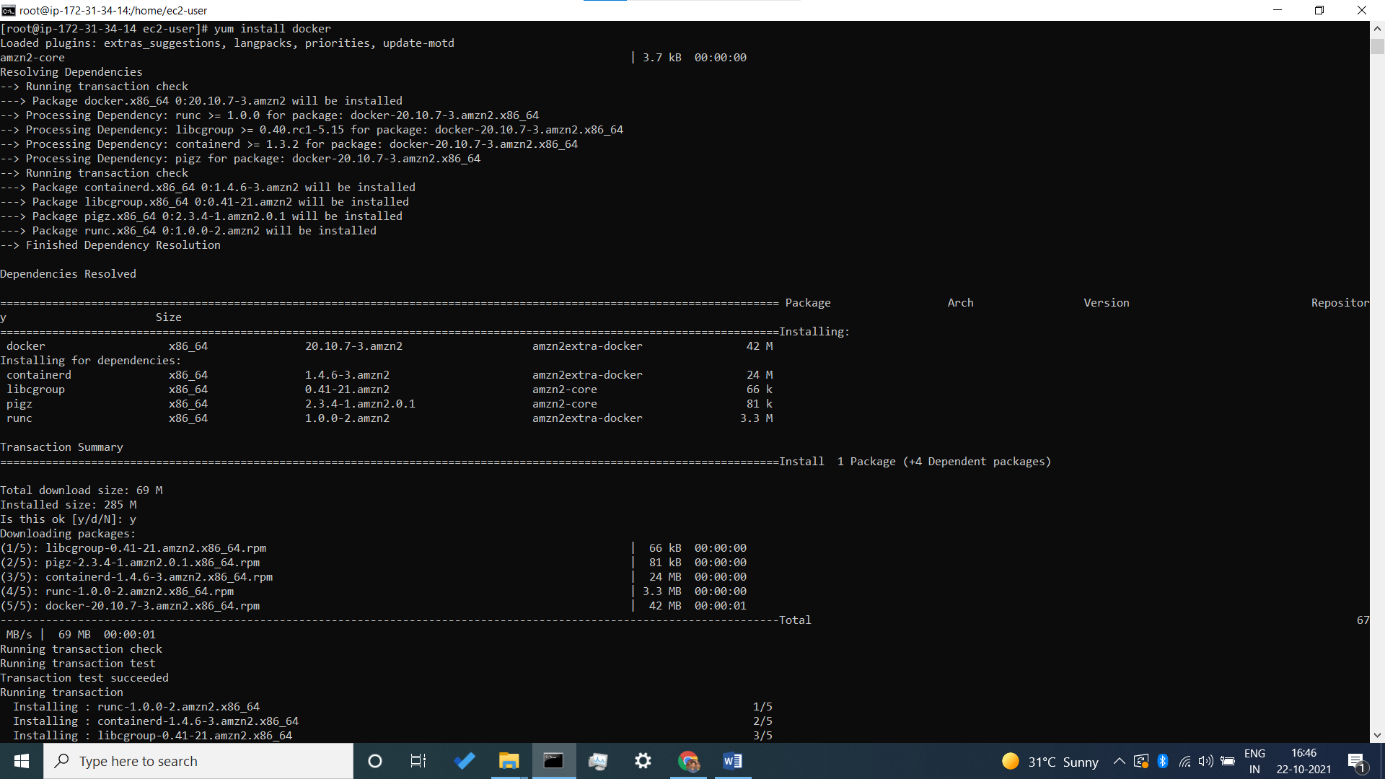

* **check Docker path**

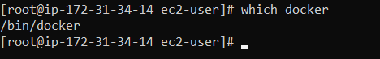

* **check Docker --version**

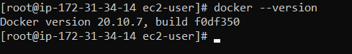

* **Basics command of Docker**

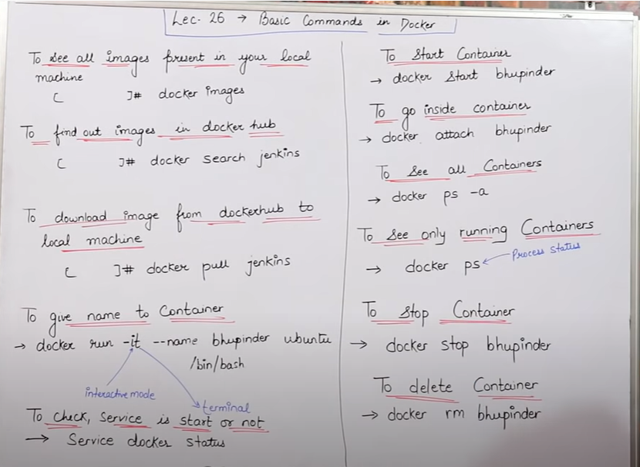

**Service docker status**

* We use this command to check our docker service is start or stop, but right now your docker service is stop.

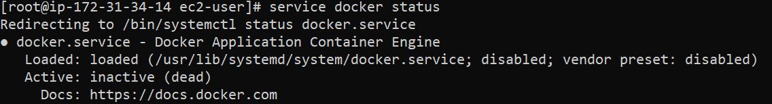

**docker info**

* You can also use this command to check your docker service is start or stop, but right now your docker service is stop.
* You also see in error your docker dameon engine is not connected to your account

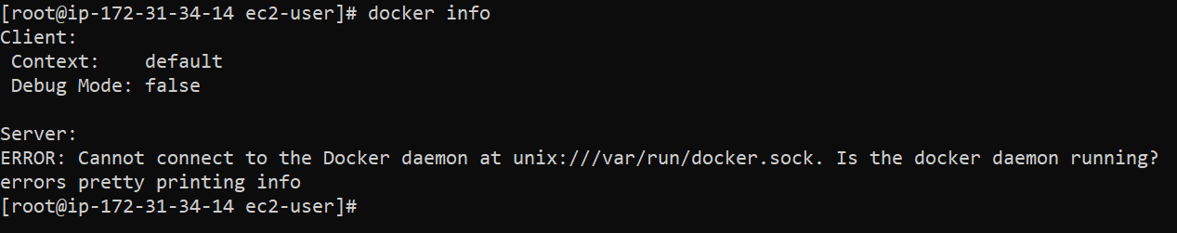

**Service docker start**

* Now, your docker service is start



**Service docker status**

* We use this command to check our docker service is start or stop, so right now our docker service is start.

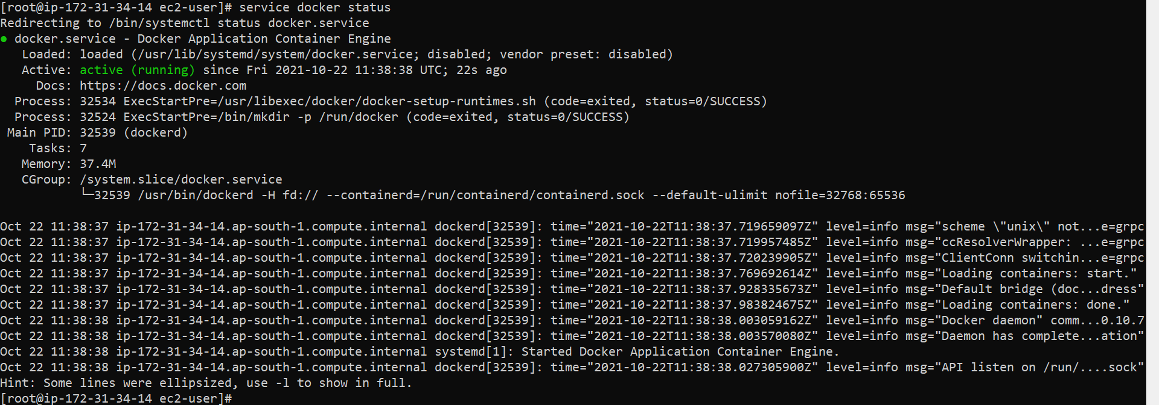

**docker info**

* Now, you see your docker service is start & you see all the detail about your docker engine .

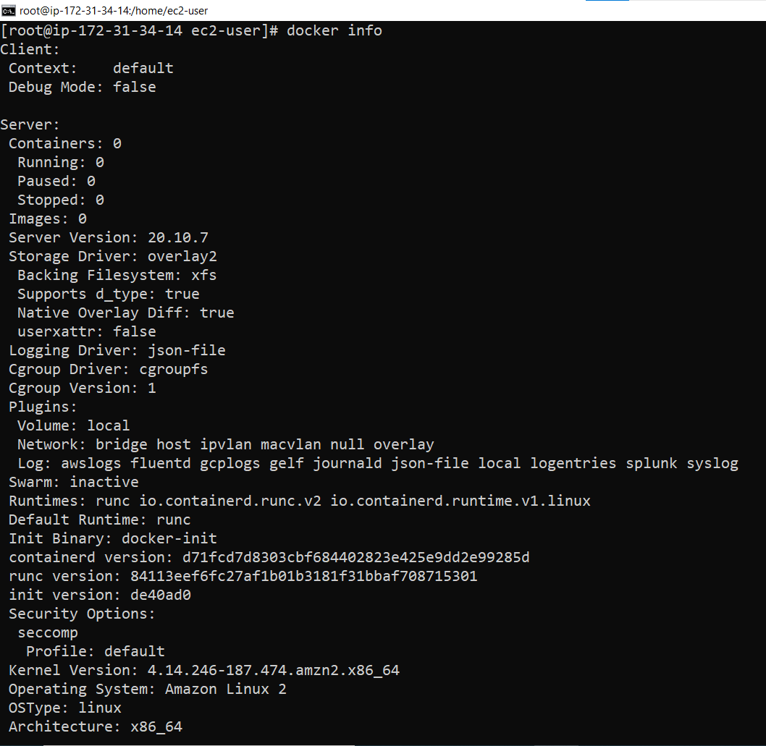

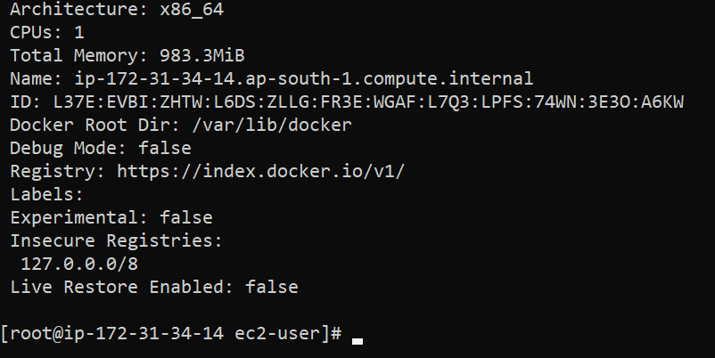

**docker images**

* We use this command to view our complete docker image in our engine, earlier we didn't create any image so now we don't have any image.

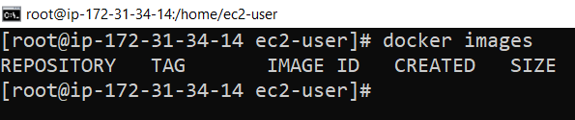

**docker container**

* If we want to see only our running container we use this command .
* docker ps



* If we want to see our whole like running or stop both container we use this command.
* docker ps-a

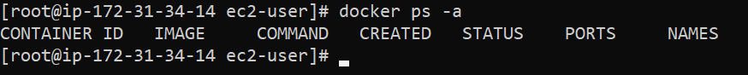

* we run this command :-

[root@ip-172-31-34-14 ec2-user]# docker run -it ubuntu /bin/bash

* agar humane ye command chalayi aur isko humare locally machine mein ye image nahi milli toh yein eak kaam ye karega ki ye humare docker hub par jayega aur vaha sein image pull karke uthaa layega.
* Hum dekh sakte hai usane eak image docker-hub sein download kiya aur apane docker engine mein usane vo image save karke rakh liya .
* Aur humane command mein run likha hai matlab ye hai ki image bana kein phir usko run kara do jisase vo container ban jaye, aur right now hum jis ubuntu image ki container ko banaya hai uskein andar hi abhi baithe hai, kyu hi hum sab sein neeche vali line mein dekhe toh root kein aage container number laga hai .

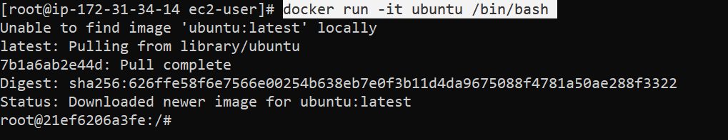

* We see container id & in container we use ls command to see all files inside a container .



* If we want to check which operating system we use in our container we use this command.
* Now lets see we use Ubuntu operating system in our container.

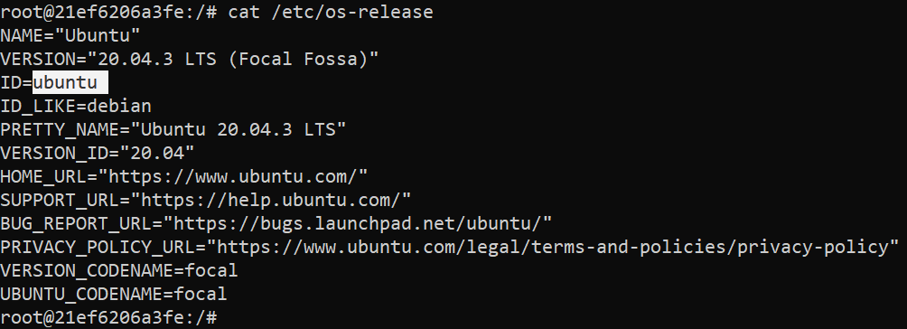

* If we want to stop our container put this command you see your container status is stopped.

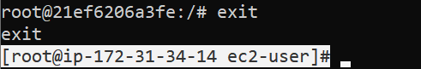

* Now we see in docker engine we have 1 image is created

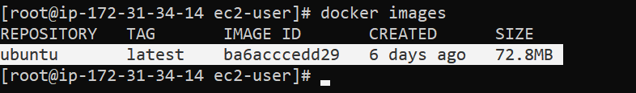

* Now lets see when again created a new image and again run the image we see we got new container id, hum jab bhi koi container ko stop karate hai aur phir sein usi container ko start karate ehai toh container id sae rehati hai but agar koi naya container banate hai toh uski container id change ho jati hai

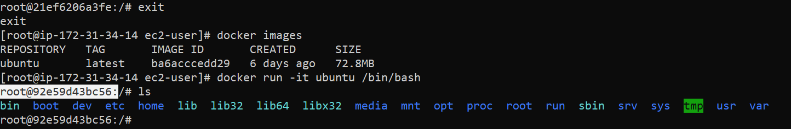

* Now we see we have two stopped containers

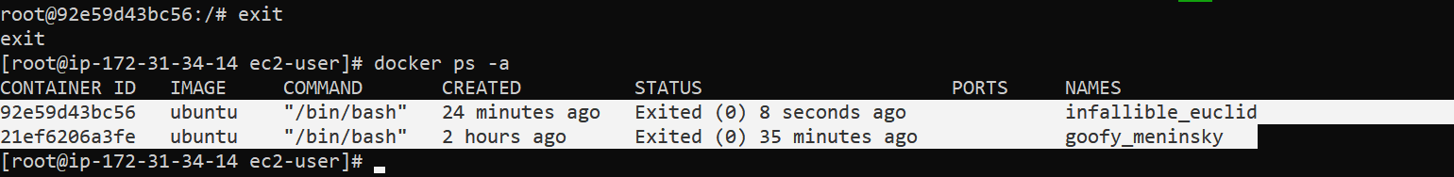

* Now we see we have only one image but we have 2 containers, it means hum eak image sein kitane bhi naye containers bana sakte hai .

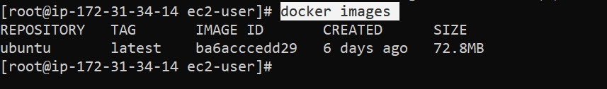

* Agar mujhe docker hub sein koi bhi image chahiye toh uske liye hum docker hub par jakar us operating system ki image ko search karenge jo humko chahihe agar vo image mil jati hai toh hum usko hi **CLI** mein command dekar image ko pull kar lenge apane engine mein kyu ki vo dockerhub par already bani pad hai.
* 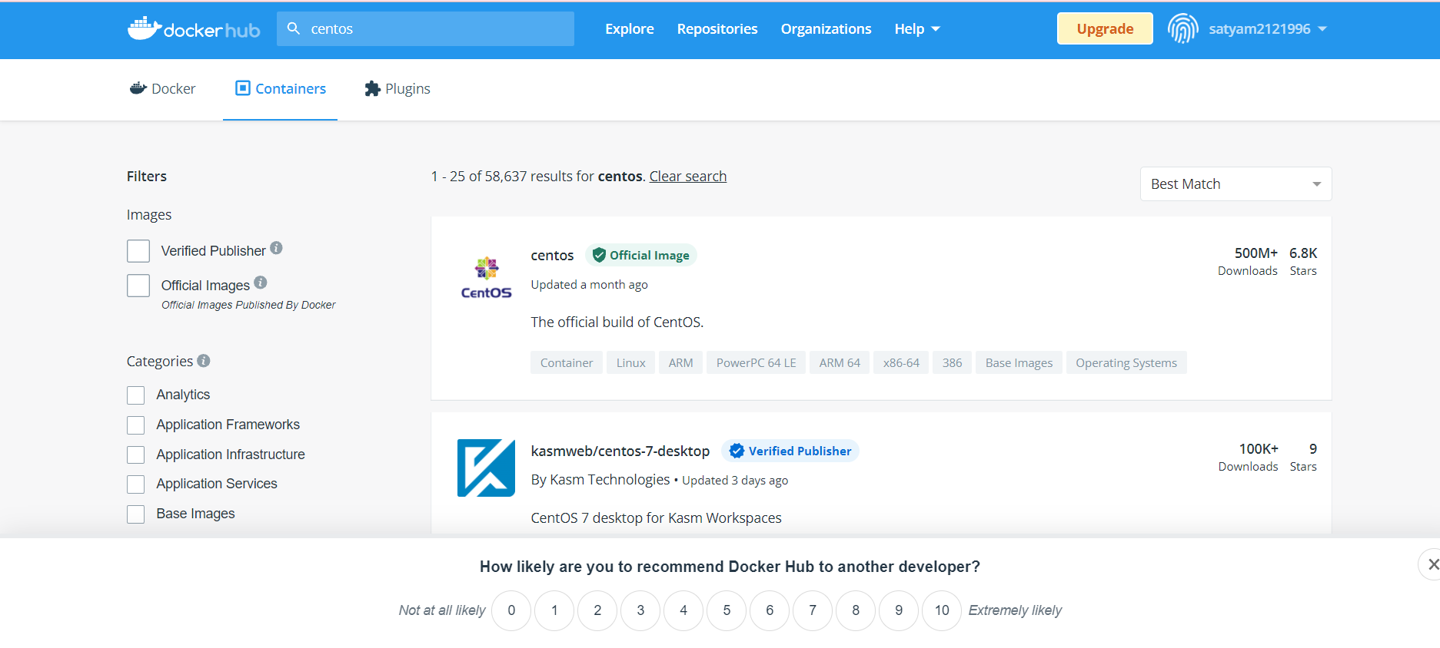

[root@ip-172-31-34-14 ec2-user]# docker run -it centos /bin/bash

* After run this command we see one centos image has been created in our docker engine.

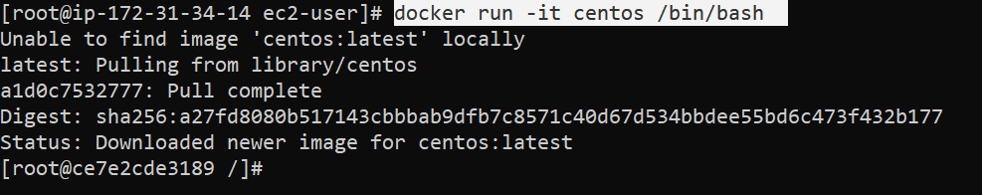

docker images

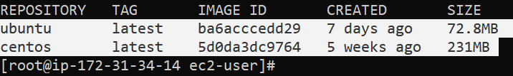

PULL IMAGES IN DOCKERHUB

* If we don’t want to only pull images in docker-hub & store image in our docker engine, we use this command.

docker pull Jenkins/Jenkins

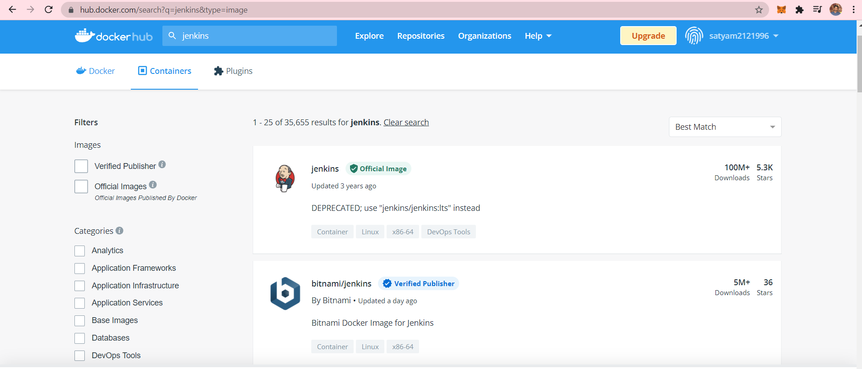

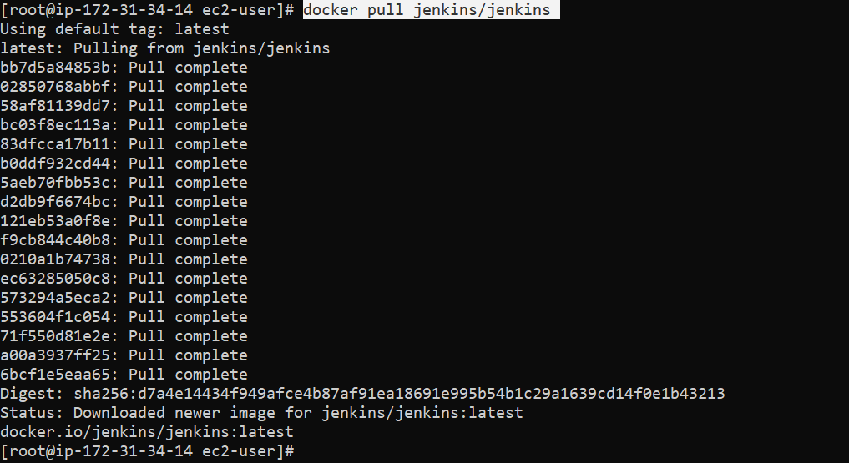

docker images

* Now, we have 3 docker images.

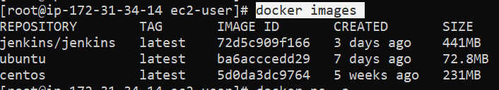

* Docker ps –a
* Hum dekhenge humare pass kewal 3 container hai aur humane abhi latest mein Jenkins image banayi but usko humane run nahi kiya isliye vo image humari container mein nahi aayega jaba tak us image ko hum run nahi karenge.

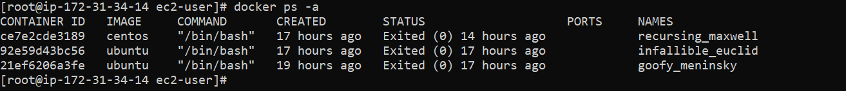

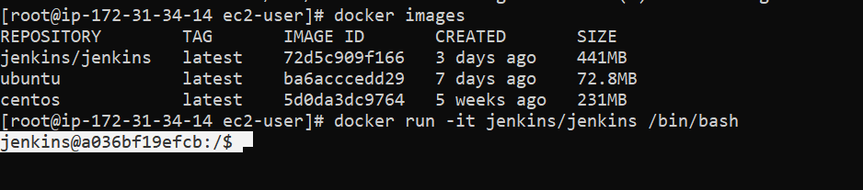

* If we have a image in our docker engine and we want to run those image we use this command

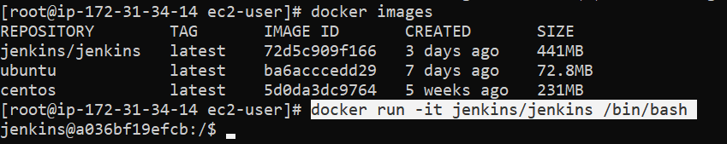

* **If we want to search docker images in CLI we use this command .**
* **Docker search jenkins**

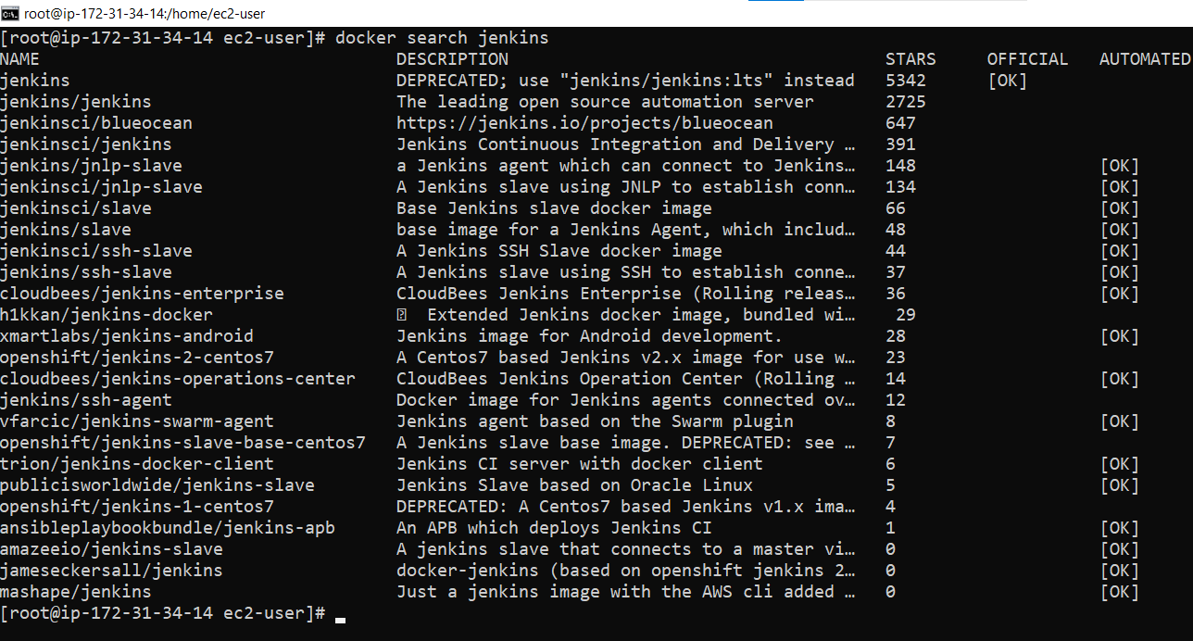

* If we want to give name to our container we use this command :-

[root@ip-172-31-34-14 ec2-user]# docker run **-it --name satyam-Tripathi** centos /bin/bash



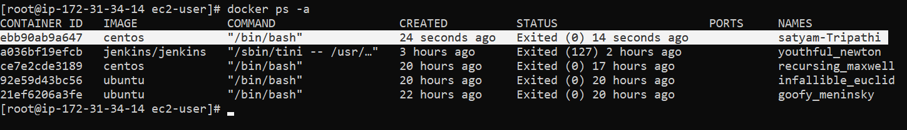

* If we want to run our stop container we use this command

[root@ip-172-31-34-14 ec2-user]# docker start **satyam-Tripathi**

* After running this command we see that our one container is running.
* Humko jab bhi koi apne stop container ko run karna ho toh us container ka hum naam de dete hai for e.x = **docker start <container name>**

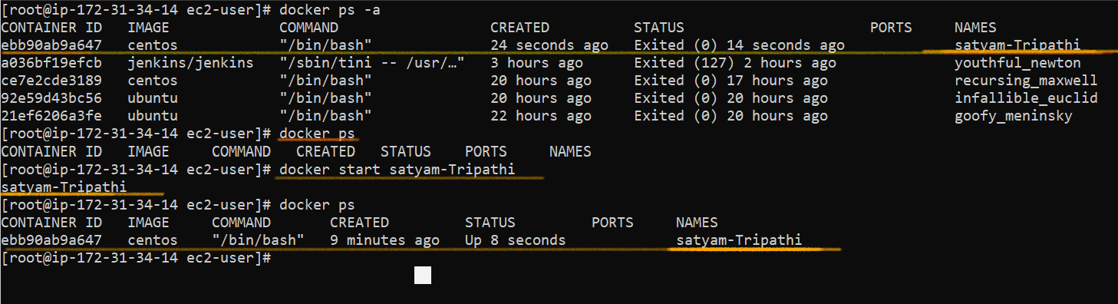

* If we want to go inside a container & do some work in our container we use this command.



* we use this command to start or stop our container

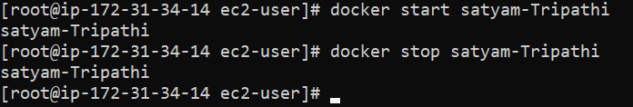

Delete container

* if we want to delete our container we use this



* If we want to **delete our container**, first we check that our container is not in running state if our container is in running state then we can't delete it, so first we stop our running container then we can run a delete command.

